CPE23 – Cognate Course 3
Apriori Algorithm
Association Rule Mining (ARM) | - A technique used to uncover interesting relationships, patterns, or associations within large datasets.  - Applied in fields such as retail and e-commerce to help understand customer purchasing patterns, detecting anomalies, and making strategic business decisions.
Basic Concepts of ARM | - For instance, in a supermarket, ARM might reveal that “customers who buy bread and butter often also buy milk”.  - If {bread, butter} then {milk}  - These rules reveal dependencies and correlations among items, often helping organizations in cross-selling, recommendation systems, and inventory management.
Transactions | Bread, Milk  Bread, Diaper, Beer, Eggs  Milk, Diaper, Beer, Coke  Bread, Milk, Diaper, Beer  Bread, Milk, Diaper, Coke
Itemset | A collection of one or more items  {Bread}  {Bread, Milk}
K-Itemset | An itemset containing exactly k-items:  {Bread, Milk} is a 2-itemset  {Bread, Milk, Diaper} is a 3-item set
Support Count (σ) | 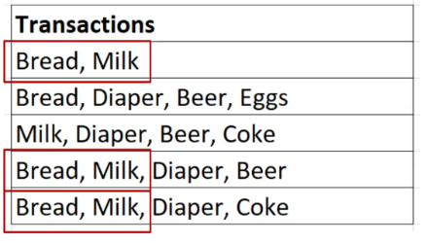  The number of transactions that include a particular itemset. For example, if {Bread, Milk} appears in 3 out 5 transactions, it’s support count is 3.
Support (s) | The proportion of transactions containing itemset, calculated as support count / total transactions  For {Milk, Bread} the support would be 3/5 = 0.6
Frequent Itemset | An itemset whose support meets or exceeds a user-defined minimum support threshold.  If minimum support threshold is set to 0.6, then {Milk, Bread} is a frequent itemset.
An Association Rule | It is an implication in the form of X -> Y, where:  X and Y are itemsets, with X as the “antecedent” (if-part) and Y as the “consequent” (then-part)  Example: {Milk, Diaper} -> {Beer}  Meaning if Milk and Diaper are purchased, Beer is also likely to be purchased.
Support (s) | How often X and Y occur together, the probability of both itemsets appearing in the same transactions  Support for {Milk, Diaper, Beer}  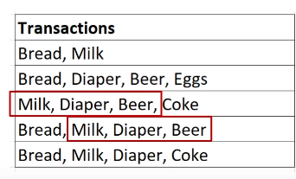  Support = {Number of transactions containing {Milk, Diaper, Beer} / (Total Transactions)  From the table, 2/5 = 0.4
Confidence | 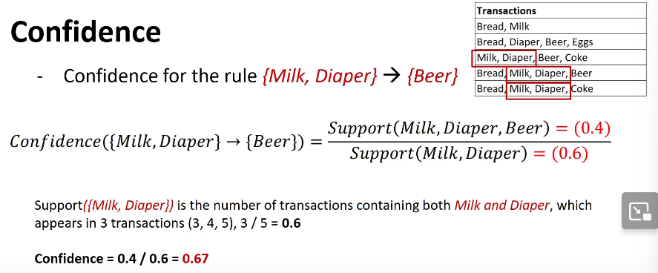
Lift | 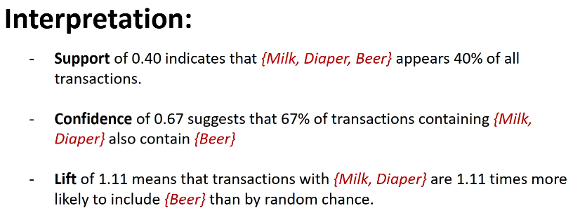  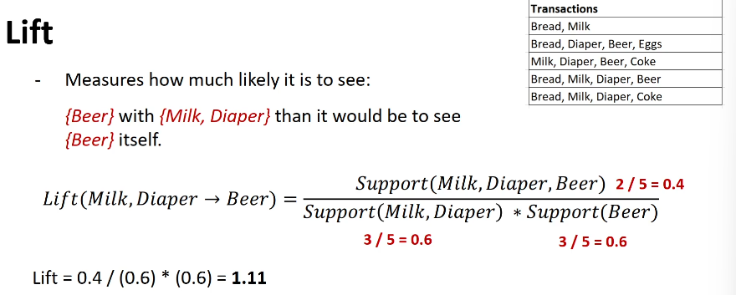  Interpretation:
Interpreting Lift Values (L > 1) | A lift of greater then 1 indicates that items in the antecedent and consequent appear together more frequently than would be expected by random chance.  Higher values signify a stronger association:  - to 1.5: Weak positive association  1.6 to 2.0: Moderate positive association  > 2.0: Strong positive association
Interpreting Lift Values (L = 1) | A lift of exactly 1 indicates that the antecedent and consequent are statistically independent. The presence of one item does not affect the likelihood of the other appearing.
Rule Generation | Once frequent itemsets are identified, rules are generated by partitioning the itemset:  For example, from the itemset {Milk, Diaper, Beer}, possible rules include:  - {Milk, Diaper} -> {Beer}  - {Diaper, Beer} -> {Milk}  - Only rules that meet the confidence threshold are retained.
Apriori Principle in Action | Suppose we have a transaction database with five transactions and a minimum support threshold of 3.  Step 1: Identify Frequent 1-Itemsets  Count each item individually across transactions  Bread appears in 4 transactions (1, 2, 4, 5) -> frequent  Milk appears in 4 transactions (1, 3, 4, 5) -> frequent  Diaper appears in 4 transactions (2, 3, 4, 5) -> frequent  Beer appears in 3 transactions (2, 3, 4) -> frequent  Coke appears in 2 transactions (3, 5) -> not frequent  Eggs appear in 1 transaction (2) -> not frequent  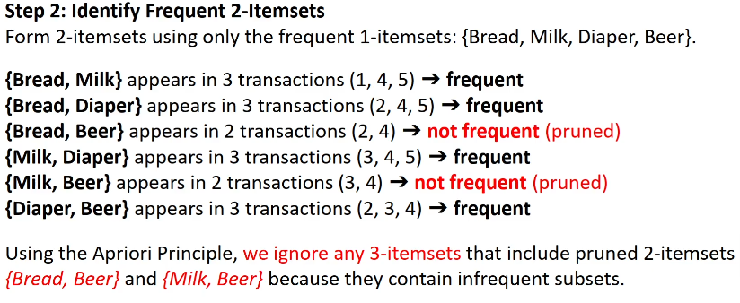  Based on the minimum support threshold, only {Bread, Milk, Diaper, Beer} are frequent 1-itemsets. We discard {Coke} and {Eggs} from further consideration.  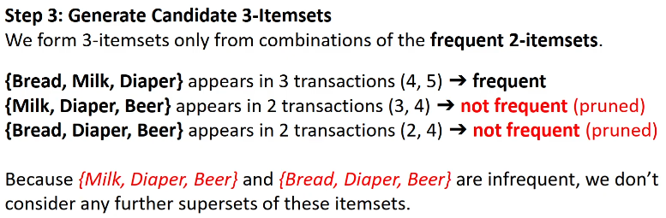
Pruning Summary | 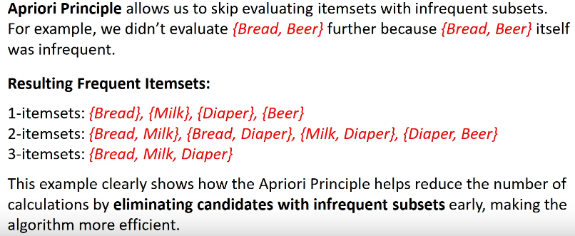
Sample Questions | 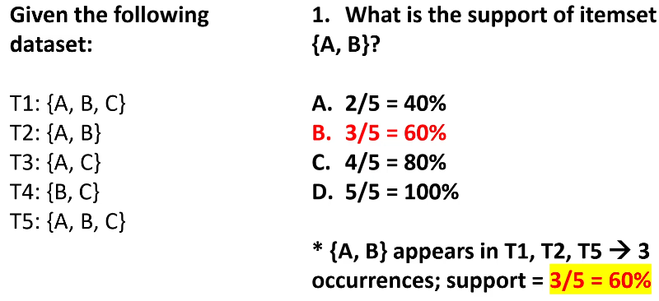  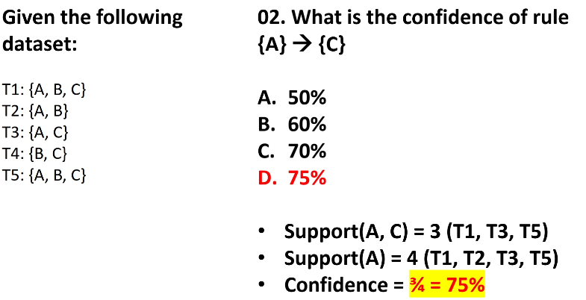  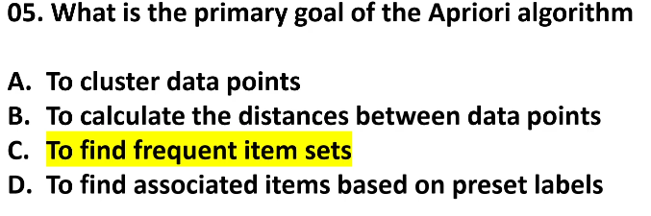  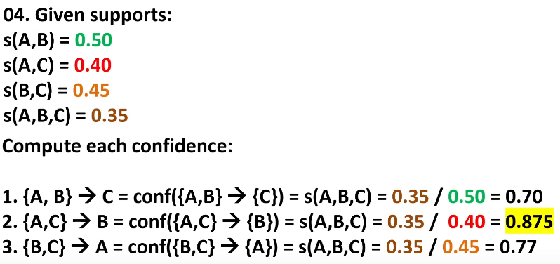  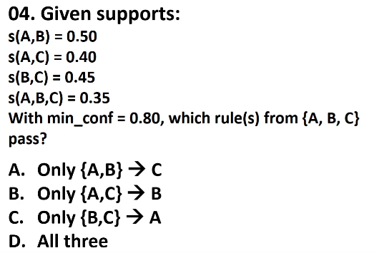  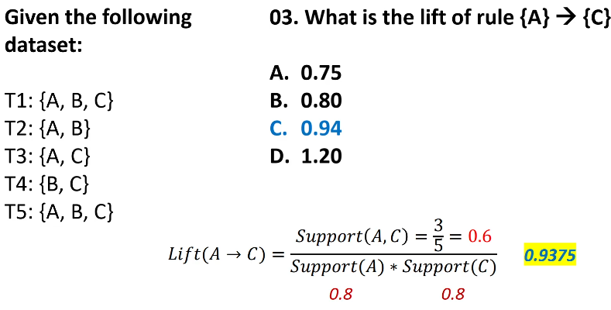  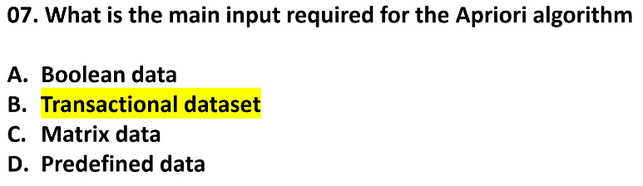  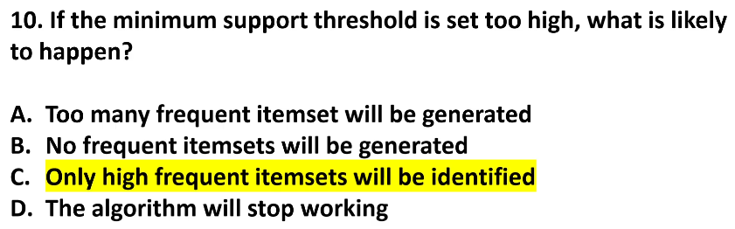  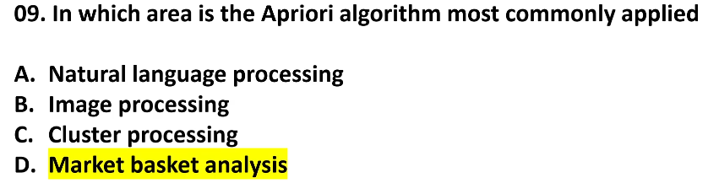  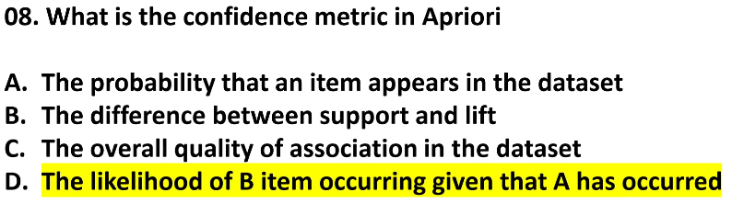

FP Growth & K-Means Clustering
FP Growth | - An algorithm for mining frequent itemsets without needs for generating candidate itemsets like Apriori.  - Particularly useful in application like market basket analysis, where it helps identify sets of products that frequently co-occur in transactions (Han, Peri, Yin; 2000)
Key Objectives of FP Growth | - Identify frequent itemset (combinations of items that frequently appear together)  - Optimize the process by reducing the computational complexity and memory requirements compared to Apriori
Core Concepts of FP Growth | - Uses a data structure called the FP-Tree (Frequent Pattern Tree) to represent transactions compactly, which facilitates efficient mining of frequent itemsets.
- FP-Tree Structure | - The FP-Tree is a compressed structure that stores frequency of each item within the data, making it easy to locate patterns.  Hierarchical Structure:  - The tree organizes items in a hierarchy based on their frequency. Each branch of the tree represents items co-occurring in transactions.  Node Paths:  - Each node in the FP-Tree represents an item and a counter indicating the frequency of that item within transactions along that path.
- Steps for Building the FP-Tree | - Count item frequency in the data.  - Sort items by frequency (descending order) to prioritize frequent items at the root, which helps compress the tree.  - Insert transactions into the FP-Tree, following the sorted order and incrementing counters for items that already exist along the paths.  - Create header tables that link to each unique item in the tree. These headers serve as the entry points for efficiency accessing and traversing nodes associated with each item.
- Pattern Extraction Using Conditional FP-Trees | - Once the FP-Tree is constructed, FP-Growth extracts patterns by constructing conditional FP-Trees for each item.  - For each item at the bottom of the FP-Tree, the algorithm collects prefix paths (paths leading to that item) and generates new trees to find frequent patterns recursively.
Advantages of FP-Growth over Apriori | - Avoids Candidate Generation  - Unlike Apriori, which generates and tests candidate itemsets at each level (1-itemset, 2-itemset, etc.). FP-Growth avoids this step altogether, significantly reduces the computational load for large data.  - Compact Representation of Data  - FP-Growth compresses the transaction database into an FP-Tree, allowing it to store the same data in a much smaller format. This is particularly helpful for dense datasets, where items frequently co-occur.  - Recursive, Divide-and-Conquer Approach  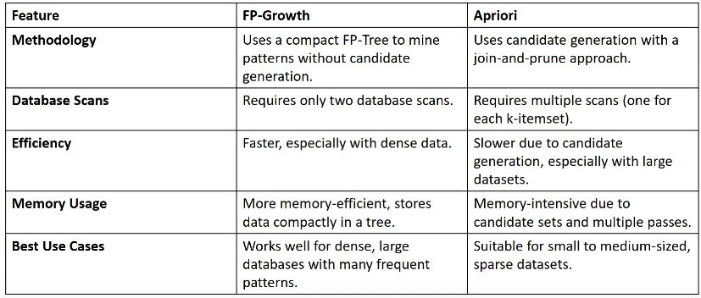  - The divide-and-conquer strategy used by FP-Growth helps in breaking down complex problems into smaller, more manageable parts, improving speed and memory efficiency.
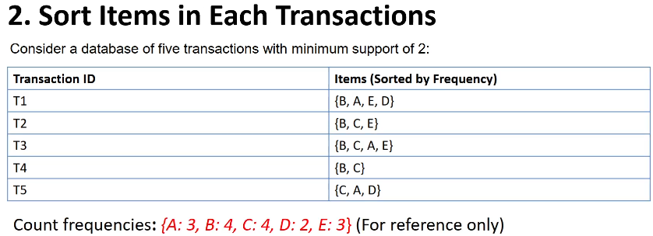
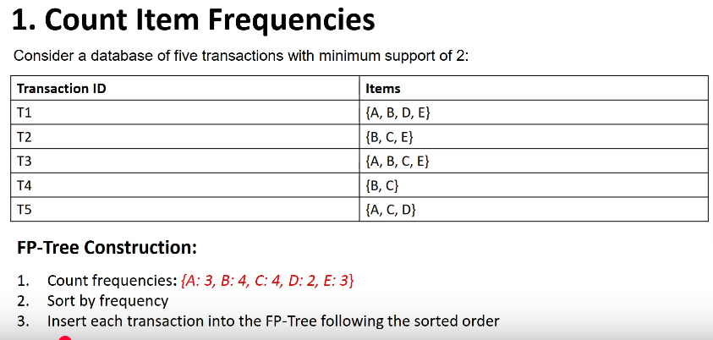
then sort:
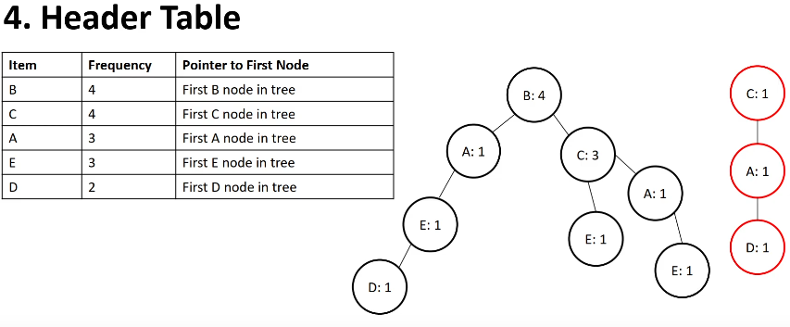
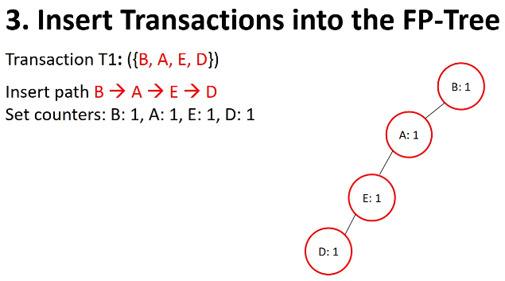

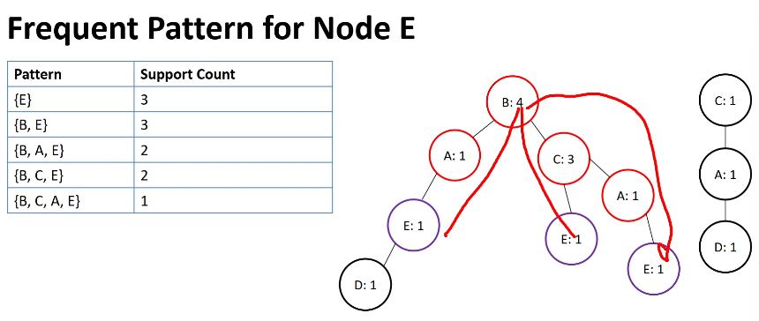
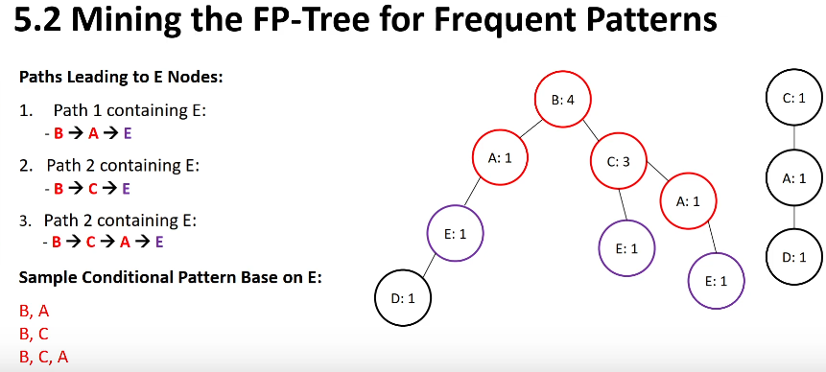
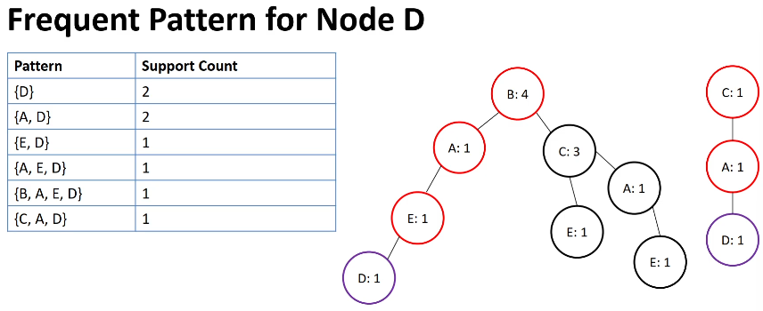
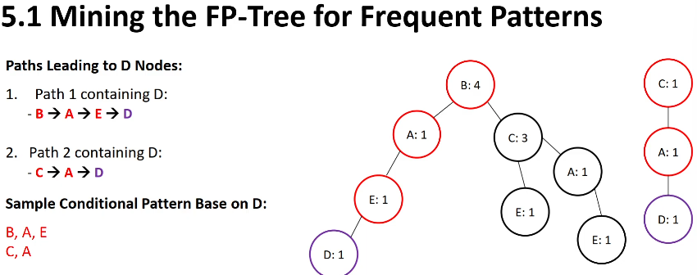

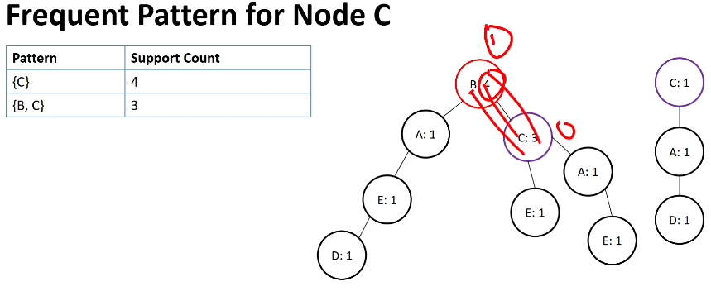
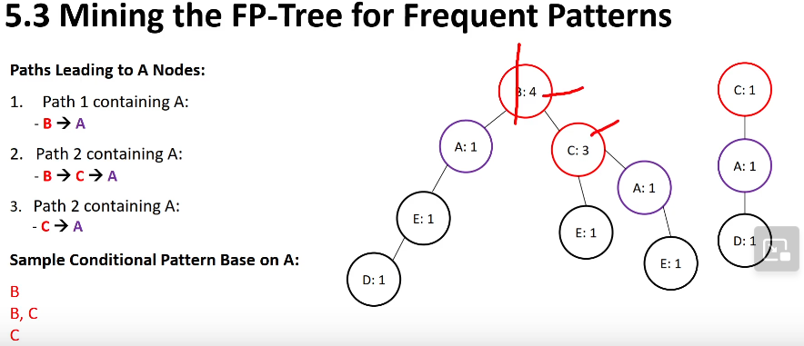
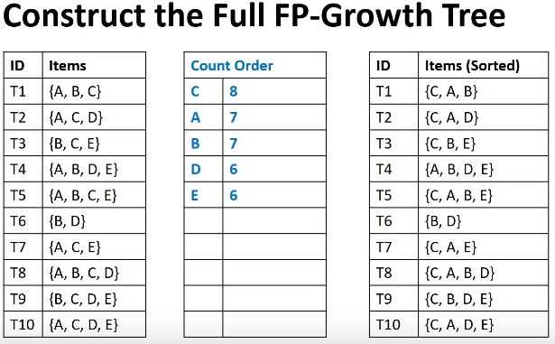

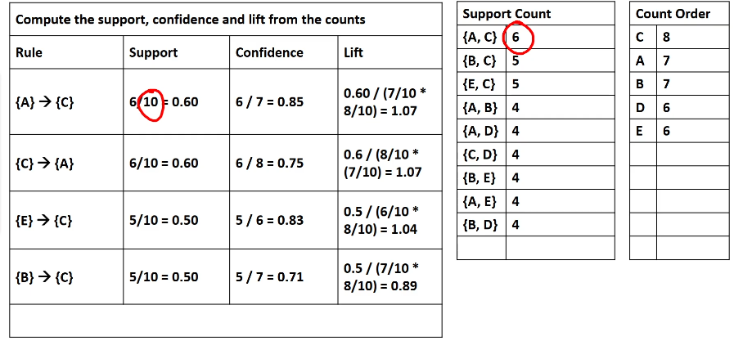
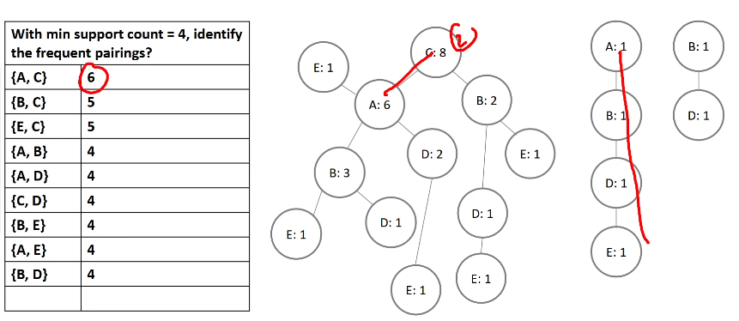
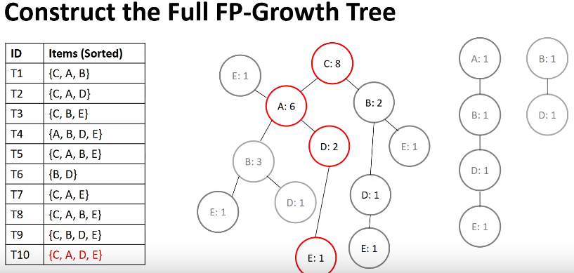

Unsupervised Learning | 